Document Revision History
(The following table lists revisions made to this document, tracked by publication version.)
#.# | Sections Modified and Description | Date | Author
1.0 | Initial release in Documentum. Legacy BN document 157114. 136886553* | 3 Aug 2015 | G Gupta
1.1 | Updated to new BH template. Fixed link 136886553* | 19 April 2021 | K Dearman
*See Support Central workflow for approval record.

Table of Contents
1.0 Purpose 3
2.0 Scope & Applicability 3
3.0 Terms, Definitions, Acronyms 3
4.0 Process Requirements & Instructions 4
4.1 High-level Flow or Process Overview 4
4.2 Process Requirements and Detailed Instructions 5
4.3 Quotation Types: 5
4.4 Quotation Selection: 5
4.5 Quotation Requirements 6
5.0 Responsibilities 8
6.0 References 8
7.0 Quality Records 8
8.0 Compliance Timeline 8
Appendix 9

Purpose
This document describes the process to define the requirements for the content and general format of Bently Nevada Services quotations

Scope & Applicability
This document applies to all Bently Nevada Services personnel who are required to produce quotations.

Terms, Definitions, Acronyms
Refer to the GE O&G QMS Lexicon for standardized terms, definitions, and acronyms. Terms may be repeated here for convenience; however, in the event of conflict, the GE O&G QMS Lexicon will take precedence.

- BH – Baker Hughes.
- ITO – Inquiry to Order
- PO – Purchase Order
- OEM – Original Equipment Manufacturer

Process Requirements & Instructions
Requests for Service Quotations will be communicated from the Sales organization or the customer

High-level Flow or Process Overview
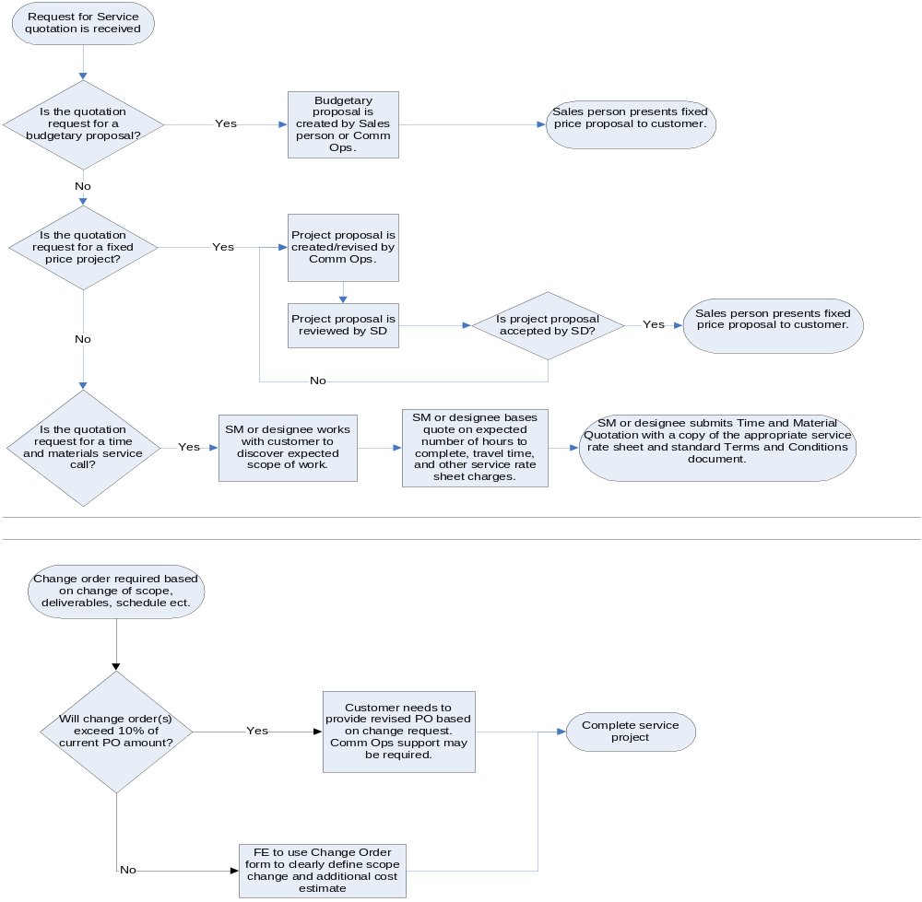

Process Requirements and Detailed Instructions
Process to communicate Service quotations from the Sales organization or the customer.

4.2.1 After receipt of an inquiry, the Service Manager will review the request, obtain clarification if necessary, and provide a time and material or work extension quotations.

4.2.2 Sales Application Engineers in Commercial Operations will be responsible for all project quotations. Service Managers will be responsible for quotations that are for in-house design work such as Electrical interconnect drawings. Site Project Managers and/or Service Managers are responsible for quotations that are for additional work on an existing project. Service Managers will be responsible for Time and Material quotations.

4.2.3 Customer received Terms and Conditions will be reviewed for exceptions or clarifications. It is the intent of the company that all products and services will be offered in accordance with MC-104 standard Terms and Conditions. Alternate Terms and Conditions should be managed per the Baker Hughes T&Cs guidelines.

4.2.4 Commercial Operations are responsible for project T&Cs.

Quotation Types:
There are several different quotation types that can be supplied. Upon review of the request and at time of further definition the quotation type will be defined. The following quotation types can be utilized depending on the request.
- Budgetary fixed price
- Time and Material
- Fixed price
- Change Orders

Quotation Selection:

4.4.1 BUDGETARY QUOTATIONS are to be used whenever the scope of work is not fully defined, or when customer has requested a quotation for procuring project funding. A Budgetary Quotation is not an offer to sell. An Order should not normally be accepted for a Budgetary Quotation.

4.4.2 TIME AND MATERIAL QUOTATIONS are utilized when the scope of work cannot be accurately determined prior to quotation deadline. This typically includes implementation and technical assistance type jobs where the customer is responsible for project management.

4.4.3 FIXED PRICE QUOTATIONS are to be used when a detailed description of the system and services being offered is required. These projects must be quoted in accordance with current ITO Process/Procedures including a Billing Milestone Schedule.

4.4.4 CHANGE ORDERS are to be used when a project or job is already in progress. For changes <10% of Contract value, Field Engineer or Service Manager may use the Change Order Form (attachment 1) or equivalent form containing at minimum: estimated additional costs, scope and reference to original PO or Project along with reference to terms and customer approval signature. For changes >10% of original Contract value, Field Engineer or Service Manager must obtain a revised PO from the customer. If the Service Manager determines that Scope has changed significantly, Change Order should be treated as a FIXED PRICE QUOTATION.

Quotation Requirements

4.5.1 Quotation pricing will be in accordance with established pricing guidelines and current ITO Process/Procedures.

4.5.2 Quotations will have a validity date. This is typically 60 days unless Customer requires different.

4.5.3 Pricing shall be lump sum except for Time and Materials quotations. Breakdowns can be supplied as required for clarification. Any breakdowns supplied will be qualified such that it is understood that the breakdown is for clarification only and CANNOT BE PURCHASED INDIVIDUALLY.

4.5.4 Terms quoted will be company standard unless otherwise formally requested by the customer. All customer terms and conditions will be handled as shown in 4.1.3 above.

4.5.5 Quotations shall have a quotation number assigned. Quotations will have a reference number assigned.

4.5.6 Quotations that are responses to formal customer requests shall identify the RFQ# and that this quotation is a response to that request. Any and all technical and commercial exceptions will be identified and noted as such. All bid forms required in RFQ will be made part of the quotation or an attachment.

4.5.7 Fixed price quotations shall reference that they are based around a defined schedule and any additional time required or delays beyond Bently Nevada Services control will be billable to the customer in accordance with the applicable rate schedule.

4.5.8 Customer supplied specifications and site requirements will be referenced in the quotation. If there are no specifications supplied the quotation will clearly state that none were supplied, and that the quotation will serve as the specification.

4.5.9 Quotations that include the supply, application, or installation of proximity probes will clearly identify shaft material and "glitch" consideration and requirements.

4.5.10 Quotations that may require modifications to Bearings will clearly state that Bently Nevada Services recommends the customer obtain OEM review and approval prior to implementation of the modification.

4.5.11 Quotations for mechanical designs, without Bently Nevada Services supplying the installation, will clearly state that Bently Nevada Services is not responsible for the implementation of the designs. Bently Nevada Services will ensure that the design is correct for its intended application.

4.5.12 Quotations that incorporate Bently Nevada manufactured hardware will not show a listing of the hardware with the applicable pricing or part numbers shown. This listing without pricing and part numbers will be incorporated into the body of the Proposal or referenced quotation that incorporates Bently Nevada manufactured hardware for which a complete definition of all parameters is not done prior to submittal, will clearly state that changes in hardware may be required, and that there is a risk that the parameter cannot be successfully measured.
4.5.12.1.1 The Proposal will clearly state that alternative or additional hardware will be an additional cost to the customer and Bently Nevada responsibility if the parameter cannot be measured. Clear definition is rarely available in retrofit projects and is only assured when designs are 100 % complete prior to implementation or have been done for like situations.

4.5.13 Customer requests may require alterations to the contents and general format described in this document.

4.5.14 Customers may negotiate Terms and Conditions.

4.5.15 Service Managers are responsible for the quality of Service Quotations.

4.5.16 Commercial Operations: Sales Application Engineers are responsible for the quality of project Proposals.

Responsibilities
Services personnel are responsible for TIME AND MATERIAL QUOTATIONS for estimated service cost. TIME AND MATERIAL QUOTATIONS will state they are in accordance with the appropriate Bently Nevada Rate Schedule and Bently Nevada Standard Terms and Conditions. The quotation is always provided with a copy of the appropriate Rate Schedule and the Terms and Conditions sheet. Also included are the following items as applicable:
  - Customer name and location.
  - Project or job as defined by the customer.
  - Objective of the Quotation. Time and Material Quotations are an offer to sell. Time, materials, and costs will be invoiced to the customer per the applicable rate schedule(s).
  - Scope of work will be briefly described stating the end objective and the services included in obtaining that objective. Customer scope required for Bently Nevada Services to implement the project or job can also be defined here. Time frame and schedule information in general context should also be identified if known.
  - Price will be the rate schedule. Any lump sum price reference shall be qualified that it is an estimate only.
  - Terms and Conditions will be identified as either Bently Nevada Standards or shall be as negotiated by corporate Contracts.
  - Any references and or attachments should be identified at the end of the quotation. This shall include as a minimum applicable rate schedule(s), and Terms and Conditions.

References
Electronic copies of published QMS documents are available online in the Document Library.
OS-172: Change Order

Quality Records
There are no quality records for this process.

Compliance Timeline
The following timeline is expected from all organizations within scope of this document.
- Full compliance upon publication

Appendix
Figure 1: Change Order Form
